I used **PyCharm** for creating the executable Python App for Microsoft Windows Operating System. The steps are as mentioned below:

1. Install **pyinstaller**
2. Run the **pyinstaller command** below to create a folder with all necessary files and assets folder so that when we run the .exe file the app is running:

**pyinstaller quadratic_eq.py --add-data "assets;assets" –windowed**

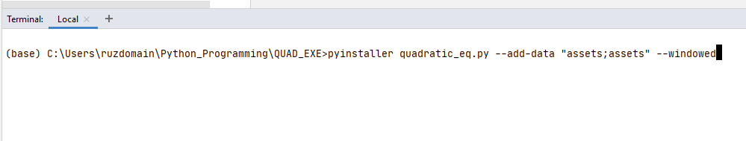

Structure of files and folders before running the pyinstaller command is as given below:

